**Task-3**

**Producer And Consumer Applied By JAVA**

**By**

**AlhaithamGamal**

**20143114**

**Problem:**

We want to make sure we will not try to add data when buffer is full or remove data from buffer if it is empty

Goal:

We take in account when buffer is full we call wake up consumer to empty buffer and if the buffer is empty we call wakeup producer to produce items

**Solution:**

We define two threads for producer and consumer and create a class PRODUCER AND CONSUMER we define two methods produce and consume in global we define linked list act as the buffer in produce method we define variable value that starts increment from zero in synchronized block in synchronized block there is two loops one infinite loop and inside it another loop where it loops if buffer is full it waits and notify consumer if buffer is not full variable value increment++ in the method consumer we define same things as producer except the inner loop condition that it loops if buffer is empty its size equal zero t waits until notify consumer if not empty it executes consuming by removing first item of the list we put synchronized to make lock for thread for not interfering .

L

Figure-1

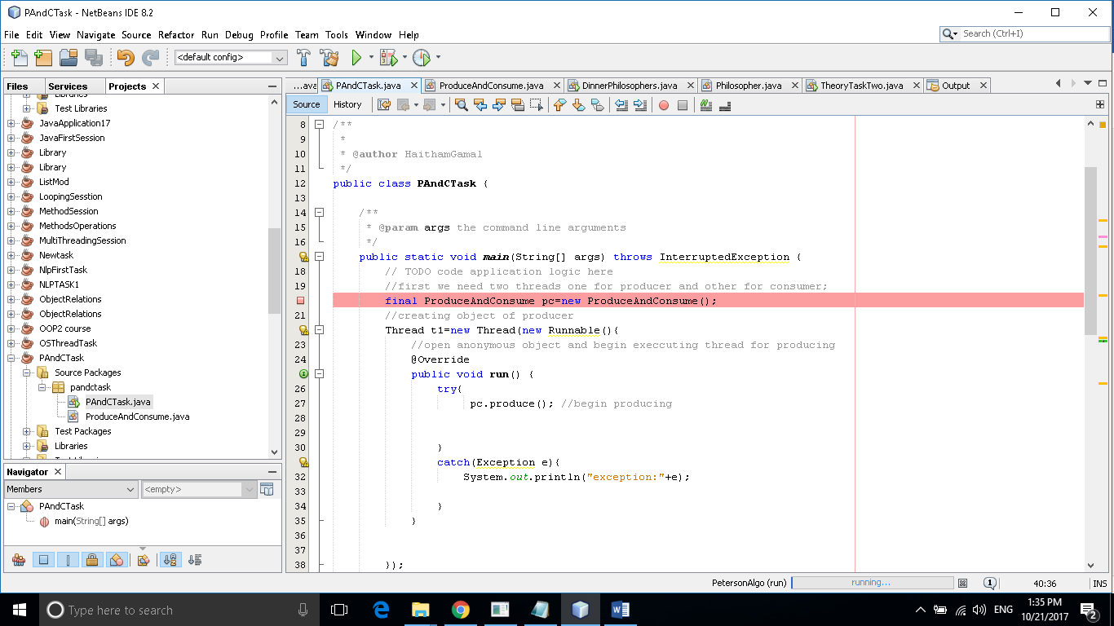

Figure-2

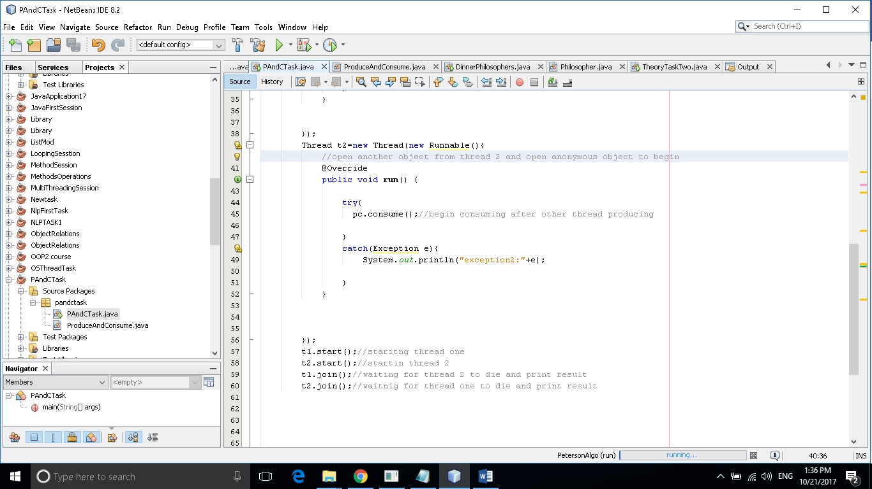

Figure(3)

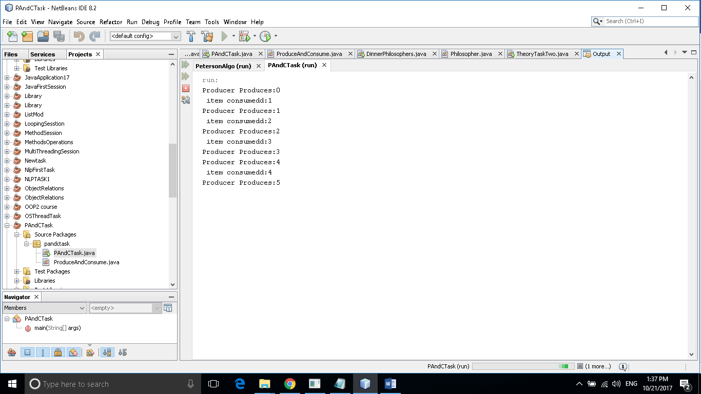

Reference:

http://www.geeksforgeeks.org/producer-consumer-solution-using-threads-java/.